Project SYNERG-E: Local Stationary Buffer Storage for High Power Charging Stations
(2) Strom, Wärmeerzeugung sowie Speicher
Karl Anton ZACH, Christian HARTL, Peter POIER⁽¹⁾, Mareike ARNDT, Wouter DEN HOLLANDER, Remco KÖHNE, Tobias WRONSKI⁽²⁾
⁽¹⁾VERBUND Solutions GmbH, ⁽²⁾Allego GmbH

Motivation
With increasing demand for high-power charging (HPC) for electric vehicles (EV), the necessity for grid connections up to 1 MW per charging site become a reality, already in 2018. This leads to an increasing problem regarding grid connection needs and costs at locations most suitable for EV charging, like highway and petrol stations. Additionally the electricity generation becomes more volatile which increases the requirements for balancing the electricity grid. By deploying local stationary buffer storage systems for HPC stations the SYNERG-E project [1] addresses both challenges and creates synergies between the energy and transport sectors.

Method
In total, ten stationary battery energy storage systems (BESS, ~0.5 MW each) are deployed in Austria and Germany in a real-life-trial to test installation and management of these BESS for a future roll-out at HPC stations. The BESS will serve the HPC stations with a reliable and cost-effective grid connection on the one hand, as well as provide grid services for TSOs.
In order to evaluate the future needs at HPC stations in terms of energy demand and the possibilities of BESS to fulfil these needs, a simulation environment was created. The simulation is divided into three sub-models, which build on one another:
- Uptake forecast model for EVs (Model A)
- Charging simulation model (Model B)
- Battery simulation model (Model C)
Model A takes into consideration different scenarios of the EV market development, charging behaviour, etc. in order to forecast the number of charging sessions and their size at HPC stations. Model B determines the expected traffic and resulting energy demand at SYNERG-E locations at a resolution of one minute, using the uptake forecast of Model A as input. Finally, Model C receives the energy demand curve of Model B and tries to minimize the peak-demand by controlling an emulated BESS.

Results and Conclusions
Using the total number of EVs – the EV stock – and its behaviour, an estimation of the demand for different charging needs (slow home, slow non-home, public fast and public ultra-fast) has been made in Model A. This demand is expressed as a number of discrete sessions by estimating the average session size. These sessions are divided over the total number of charge points (CP) to arrive at a number of sessions per CP (see Figure 1 below).

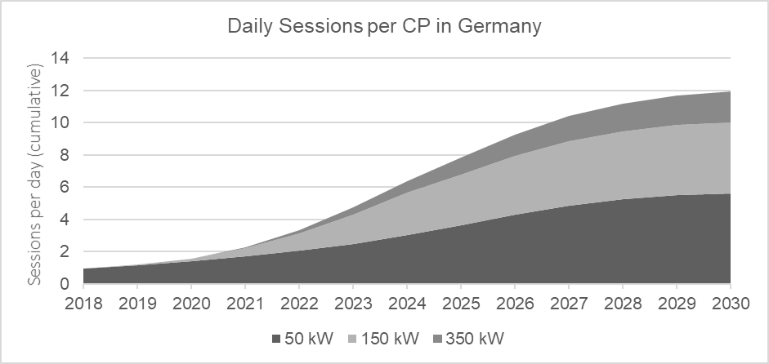
Figure 1: Daily charging sessions per CP in Germany up to 2030
The forecasted uptake is the main input to Model B, but a few additional variables are required:
- Location lay-out (limiting the number of simultaneous sessions)
- Temporal distributions of sessions
- Session size distributions (duration of charging events)
- Different load curves from actual charging sessions
By taking these variables into consideration, realistic energy demand patterns of a HPC stations can be established in Model B from 2018 up to 2030. Figure 2 exemplary shows the simulated grid load of three days of charging sessions at a HPC station in 2030.
[kW]
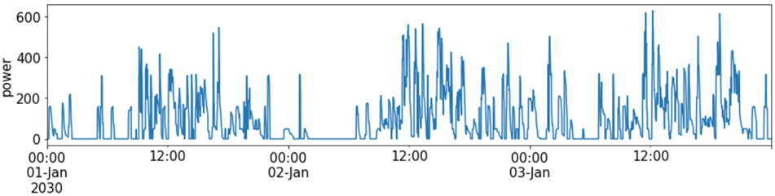
Figure 2: Simulated grid load of three days of charging sessions at a HPC station in 2030

Finally, the peak-shaving operation of the BESS is simulated in Model C, taking the output of Model B as an input. Additionally, different BESS parameters (power, energy capacity, efficiency, min./max. state of charge, etc.) and settings (target max. grid power demand, etc.) are taken into consideration. Multiple simulation runs with varying parameters and settings have been conducted – a selected result of these runs is shown in the figure below.

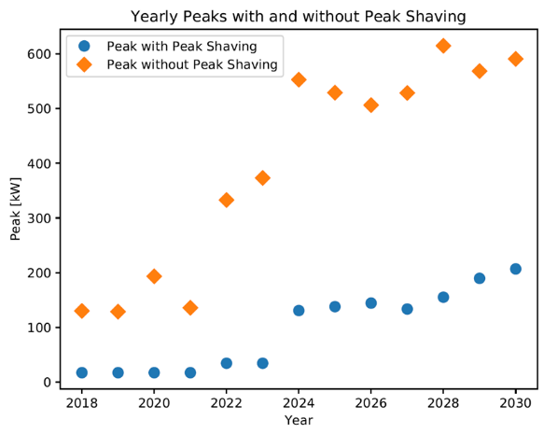
Figure 3: Selected result of Model C: A comparison of the achievable peak vs. peak without BESS

The choice of the target grid power limit for the averaged-power peak-shaving function (i.e. 15-minute average) of the BESS impacts the actual grid power peak that can be achieved – if the target is too ambitious the achieved peak will be higher than the target value. Figure 3 shows the “best peak”, i.e. the lowest value of 15-minute average power demand, that can be achieved with the peak-shaving operation of a 500 kW / 500 kWh BESS for each year within the range 2018-2030.

As can be seen from this plot, it appears possible to achieve significant (and increasing) cuts in peak power and therefore also in the corresponding cost (i.e. grid fees) due to peak-shaving operation of the BESS at the HPC location up to the year 2030 and possibly beyond.

Literature
[1] SYNERG-E project website: www.synerg-e-project.eu

Europaplatz 2, 1150 Wien, +43 (0)50313 – 52296, karl.zach@verbund.com, www.verbund.com

