Bias-correcting simulated wind power in Austria and in Brazil from the ERA-5 reanalysis data set with the DTU Wind Atlas
Modelling
Katharina GRUBER⁽¹⁾, Johannes SCHMIDT⁽¹⁾
⁽¹⁾ Institut für Nachhaltige Wirtschaftsentwicklung, Universität für Bodenkultur Wien

Motivation und zentrale Fragestellung
Scenarios of future energy systems with high shares of intermittent renewables rely on timeseries data of potential generation to understand renewable variability. This data may come from measured generation. Yet, these measurements are not (freely) available for all world regions [1,2]. As an alternative, reanalysis climate data, which are freely available globally are used to simulate intermittent electricity generation. [2,3,4]. However, significant regional bias is present in reanalysis data. We therefore study bias correction of ERA-5 reanalysis wind speed data in Austria and Brazil to understand if the same bias correction methods can improve timeseries in two climatically different regions.
Methodische Vorgangsweise
This work is based on ERA-5 reanalysis [5] wind speed data and on DTU’s Wind Atlas [6] mean wind speeds. Both datasets are available globally and are tested in two countries, Brazil and Austria. First, wind speeds at locations of wind parks (Brazil) or wind turbines (Austria) are determined and consequently used to simulate wind power generation with a generic power curve and information on the installed capacity. In a second step, wind speeds are bias corrected with the help of mean wind speeds of the Wind Atlas before wind power simulation. Simulated time series are then compared to time series of observed wind power generation from the National System Operator of Brazil (Operador Nacional do Sistema Eletrico, ONS [7]) and the Settlement Agency for Green Electricity (OeMAG Abwicklungsstelle für Ökostrom AG [8]). Statistical parameters (RMSE, MBE and means) are examined, as well as ranges of simulated and observed wind power generation to assess the effect of wind speed bias correction with mean wind speeds of the Wind Atlas on the quality of wind power simulation. By comparison of results in two different countries conclusions on the quality of global simulation with wind power correction will be attempted.
Ergebnisse und Schlussfolgerungen
Results show a similar outcome for bias correction of simulations of wind power generation in Brazil and Austria. Table 1 indicates that in Austria, when Wind Atlas mean wind speeds are applied for bias correction, the RMSE as well as the MBE are increased. The positive MBE and the higher mean show that performing wind speed correction leads to a considerable overestimation of observed wind power generation, but underestimates before wind speed bias correction. This is also shown in Figure 1, where before wind speed correction the simulated wind power is close, but slightly below observed wind power generation. Bias correction, however, increases simulated wind power and thus results in significant overestimation.
In Brazil the effects of wind speed bias correction with Wind Atlas data shows a similar but slightly different effect: The MBE as well as the difference to the observed mean generation are increased. The RMSE, however, unlike in the Austrian simulation, is lower after bias correction.
The model does not account for concrete turbine specifications yet, but applies a generic power curve. This may be one major source of bias in our estimates. Further work and validation are necessary to come to a definite conclusion on the usefulness of Global Wind Atlas data for bias-correction.

Table 1: Statistical parameters for comparison of observed (obs, data by OeMAG and ONS) and simulated daily wind power generation with (wpc) and without (wp) Wind Atlas mean wind speed correction in Austria (aut) and Brazil (bra)

 | wp_aut | wpc_aut | obs_aut | wp_bra | wpc_bra | obs_bra
RMSE [GWh] | 1.80 | 4.43 |  | 11.52 | 9.93
MBE [GWh] | -0.33 | 2.85 |  | -1.58 | 3.69
Mean [GWh] | 6.68 | 9.86 | 7.02 | 24.68 | 29.95 | 26.26

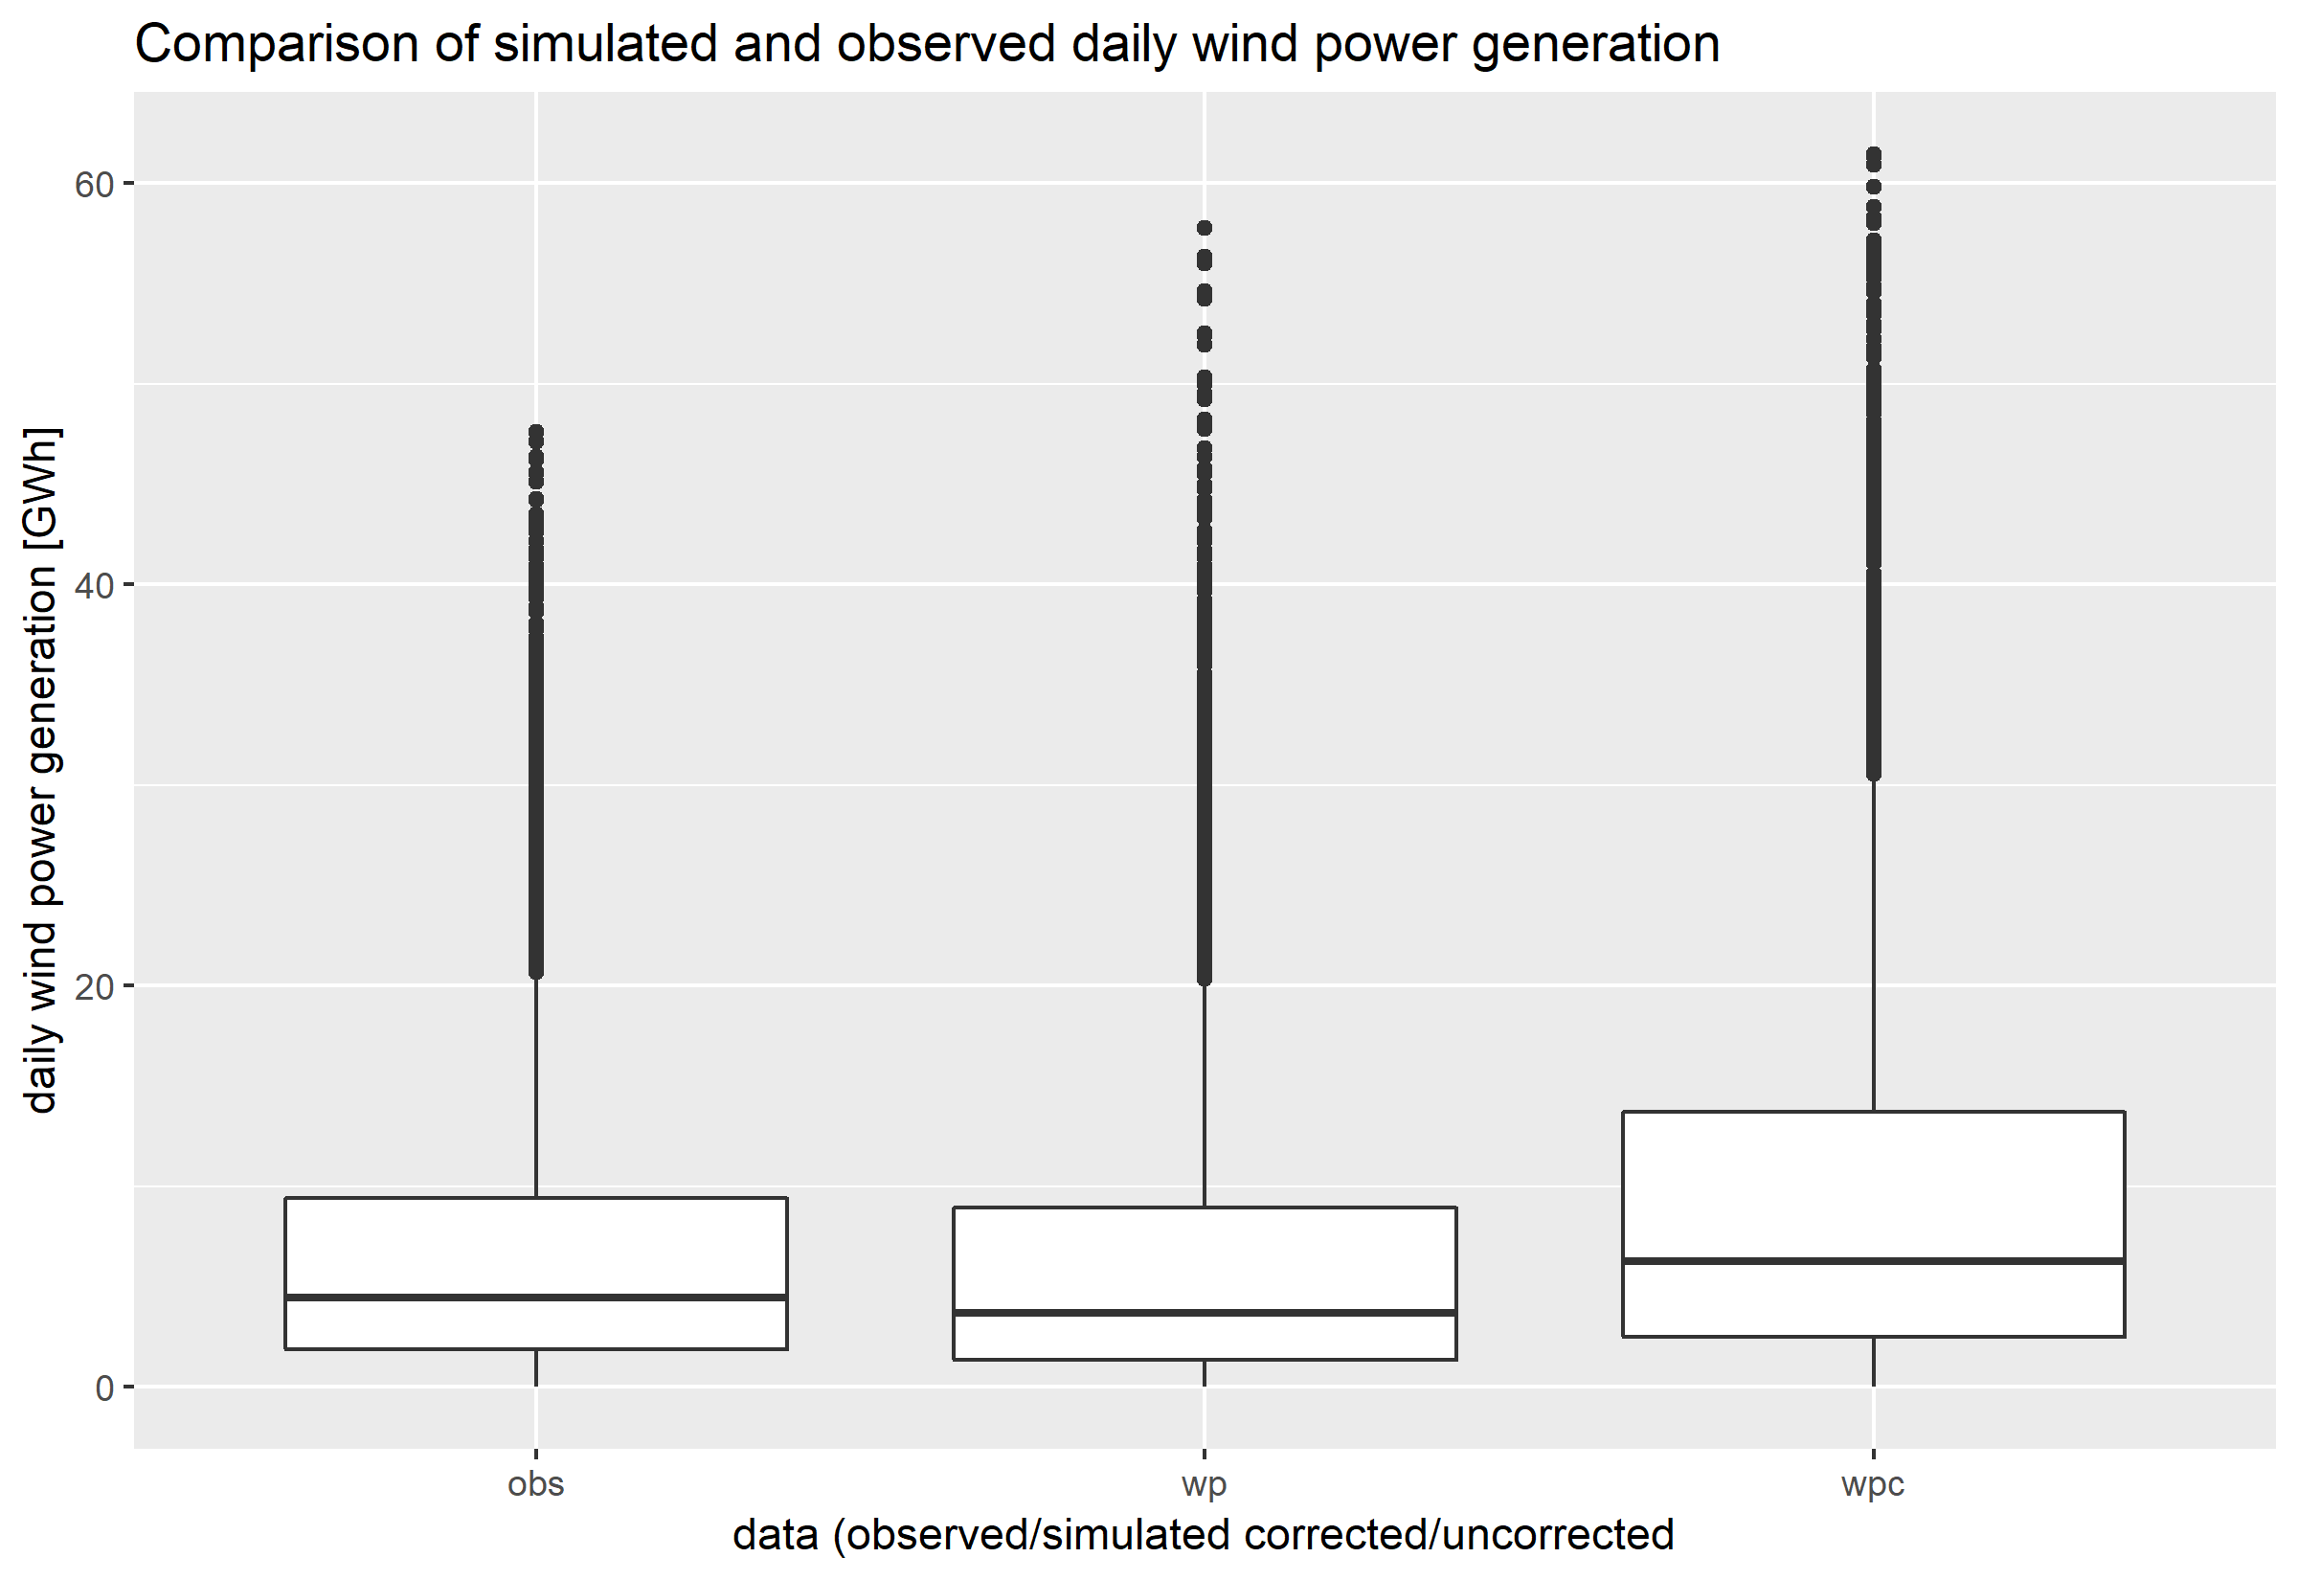
Figure 1: Comparison of observed (obs, data by OeMAG) and simulated daily wind power generation with (wpc) and without (wp) Wind Atlas mean wind speed correction in Austria

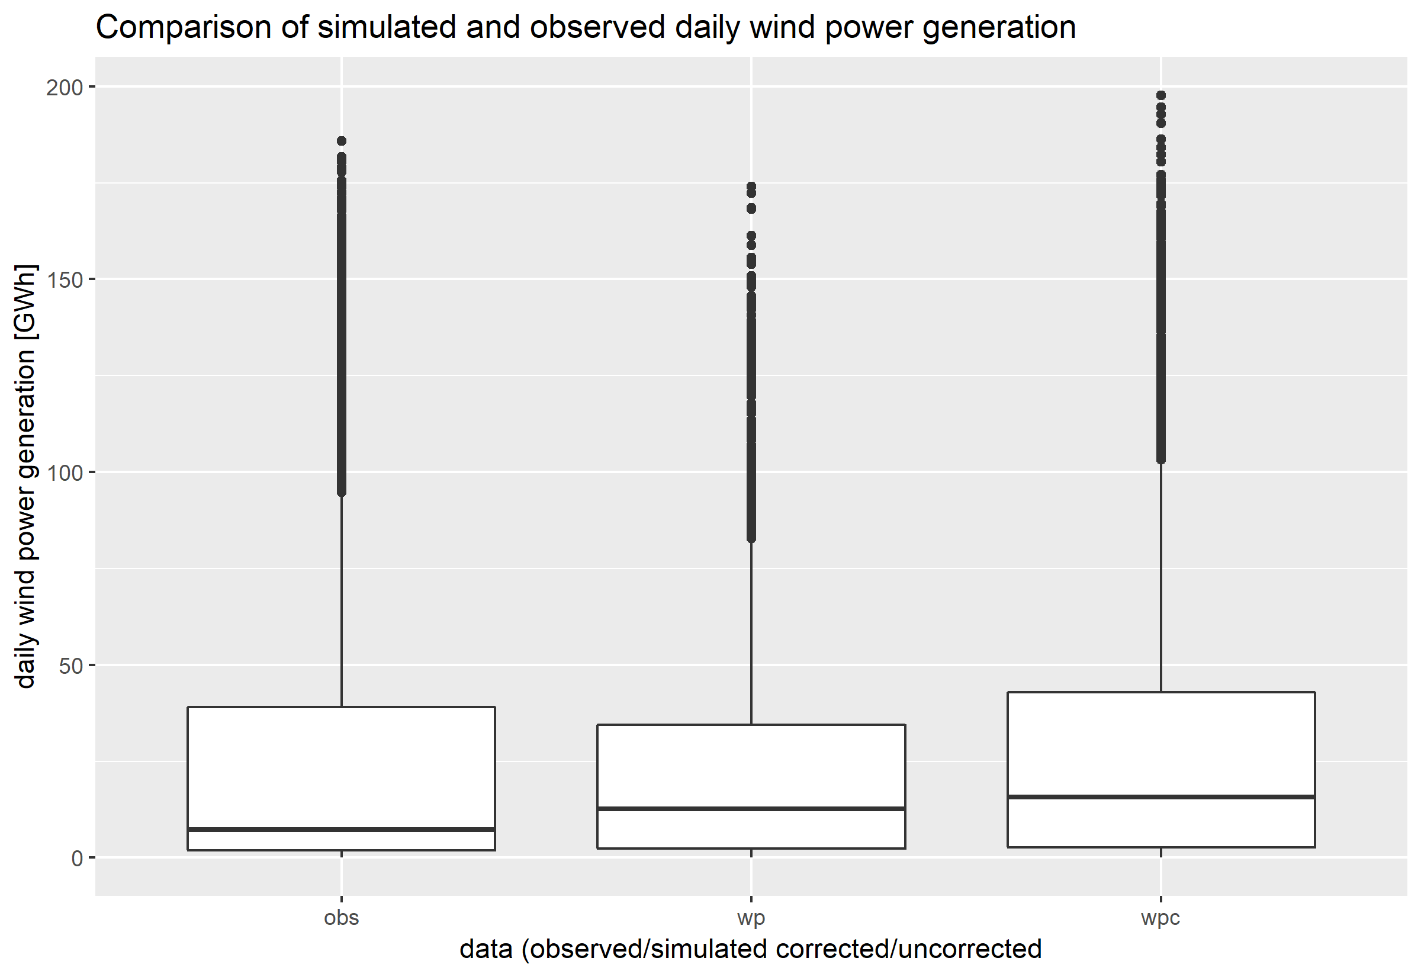
Figure 2: Comparison of observed (obs, data by ONS) and simulated daily wind power generation with (wpc) and without (wp) Wind Atlas mean wind speed correction in Brazil
Literatur
[1] S. Pfenninger and I. Staffell, “Using bias-corrected reanalysis to simulate current and future wind power output,” Energy, pp. 1224-1239, November 2016.
[2] S. Pfenninger and I. Staffell, “Long-term patterns of European PV output using 30 years of validated hourly reanalysis and satellite data,” Energy, pp. 1251-1265, November 2016.
[3] L. Bengtsson, S. Hagemann and K. I. Hodges, “Can climate trends be calculated from reanalysis data?,” Journal of Geophysical Research, 16 June 2004.
[4] D. J. Cannon, D. J. Baryshaw, J. Methven, P. J. Coker and D. Lenaghan, “Using reanalysis data to quantify extreme wind power generation statistics: A 33 year case study in Great Britain,” Renewable Energy, pp. 767-778, March 2015.
[5] ECMWF, „ERA5“, 06 11 2018. [Online]. Available: https://www.ecmwf.int/en/forecasts/datasets/archive-datasets/reanalysis-datasets/era5
[6] IRENA, „DTU Global Wind Atlas 1 km resolution“, 06 11 2018 [Online]. Available: https://irena.masdar.ac.ae/gallery/#map/103
[7] ONS, „geração de energia“, 06 11 2018. [Online]. Avaiable: http://ons.org.br/Paginas/resultados-da-operacao/historico-da-operacao/geracao_energia.aspx
[8] OeMAG, „Winderzeugung“, 06 11 2018. [Online]. Available: https://www.oem-ag.at/de/oekostromneu/winderzeugung/

Jungautor. Feistmantelstraße 4, 1180 Wien, +43 1 47654-73128, katharina.gruber@boku.ac.at, Web

